[DP-20] Accessibility options for people with disabilities are not display on the app
Created: 04/May/24 Updated: 05/May/24
Status: | To Do
Project: | Dominos Pizza

Type: | Bug | Priority: | High
Reporter: | Tomer Darmon | Assignee: | Unassigned
Environment: | - One plus 11 5G Android version : 14  - Samsung Galaxy S10 Android version 12

Attachments: | 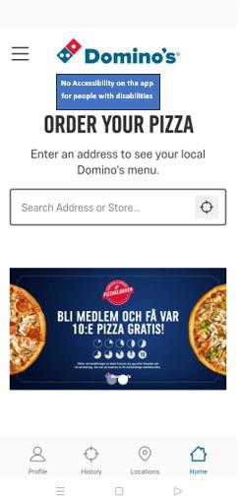
Severity: | S3 - Critical
Description

Steps to Reproduce :
- Enter the app Domino's Pizza
- Check for accessibility symbols on the screen
Actual Result : The is no any symbol for accessibility tools for people with disabilities.
Expected Result : Expect that the app would be accessible for people with disabilities
and would offer them several options to make the use in the app better and easier for them.

37

